1. Architecture Overview
The proposed Cloud Cost Intelligence pipeline follows a modern ELT (Extract, Load, Transform) architecture. Instead of transforming data before loading it, we extract raw billing logs from the source clouds, load them into a centralized Data Lake/Warehouse, and then perform transformations using SQL-based tools like dbt. The pipeline runs on a daily batch schedule (at 02:00 UTC) to ensure all previous day's billing data is captured.
2. Pipeline Components
A. Data Sources
- AWS: Cost & Usage Reports (CUR) delivered as CSV files to an S3 Bucket.
- GCP: Cloud Billing Export delivered as CSV/JSON to a Google Cloud Storage (GCS) bucket.
B. Ingestion Process (Extract & Load)
- Orchestration: Apache Airflow is used to schedule and manage the workflow.
- Mechanism: A Python-based "Extract" task runs daily. It connects to the source buckets (AWS S3 & GCP GCS), identifies new files for the specific date partition, and copies them to our central Data Lake.
- Raw Storage Layer: Data is landed unchanged in the Raw Zone of the Data Lake (e.g., S3 bucket raw/billing/{provider}/{YYYY}/{MM}/{DD}/). This ensures an immutable backup of the source data is always available for auditing or re-processing.
- Pattern: Batch Processing
- Rationale: Cloud billing data is delivered by providers (AWS/GCP) as static CSV files once or twice a day, not as a continuous real-time stream. Therefore, a Batch ingestion pattern is the most efficient and cost-effective approach. Real-time streaming is unnecessary and would add complexity without value for this use case.
- Scheduling:
- Frequency: Daily.
- Time: 02:00 UTC.
- Logic: The schedule is set to run 2 hours after the UTC day closes to ensure the cloud providers have finished writing the previous day's logs to the source buckets.
- Orchestration:
- Tool: Apache Airflow.
- Workflow: An Airflow DAG (Directed Acyclic Graph) triggers the ingestion task, retries automatically if the source file is missing, and alerts the team if the file is delayed by more than 4 hours.

C. Transformations (Transform) Once the raw data is loaded into the Data Warehouse (e.g., Snowflake or BigQuery), dbt (data build tool) triggers the transformation logic:
- Staging (Clean): Standardizes column names (e.g., renaming ProjectID to resource_id), casts data types, and filters out null header rows.
- Intermediate (Unify): Performs the UNION ALL operation to merge AWS and GCP data into a single stream.
- Serving (Model): Materializes the data into the Star Schema designed in Part B (Fact/Dimension tables), ready for analysis.
D. Data Validation
Automated quality checks are integrated directly into the pipeline using Great Expectations or dbt tests:
- Schema Tests: Ensure no critical columns (Date, Cost, Service) are null.
- Business Logic Tests: Verify cost_usd is never negative (unless marked as a credit/refund).
- Volume Tests: Alert if the row count drops by >20% compared to the 7-day rolling average.
E. Monitoring & Alerting
- Pipeline Health: Airflow sends Slack notifications immediately if any task (Ingest, Load, or Transform) fails.
- Cost Anomaly Detection: A final SQL check runs after the pipeline finishes. If the total daily spend exceeds a defined threshold (e.g., $10,000) or spikes by >50% day-over-day, a "High Priority" alert is sent to the FinOps email alias.
F. Storage Layers
The data pipeline moves data through three distinct layers of quality to ensure traceability and integrity:
- Layer 1: Raw (Bronze)
  - Storage: Object Storage (AWS S3 / GCP Cloud Storage).
  - Format: Original CSV files (compressed).
  - Purpose: An immutable backup. If a transformation error occurs later, we can always "replay" the pipeline from this raw data without needing to ask the cloud provider for the files again.
- Layer 2: Cleaned (Silver)
  - Storage: Data Warehouse Staging Tables.
  - Transformations:
    - Standardization of column names (e.g., renaming c1 → date).
    - Data typing (casting strings to decimals/dates).
    - Handling missing headers (filtering out rows where date = 'date').
  - Purpose: To have a queryable version of the data that is structurally correct but hasn't yet been joined or aggregated.
- Layer 3: Analytics (Gold)
  - Storage: Data Warehouse Serving Tables (Star Schema).
  - Transformations:
    - UNION ALL to merge AWS and GCP data.
    - Joins between Fact and Dimension tables.
    - Business logic application (e.g., tagging cost centers).
  - Purpose: This is the "Product" layer used by dashboards (Tableau/Looker) and analysts. It is optimized for read performance.
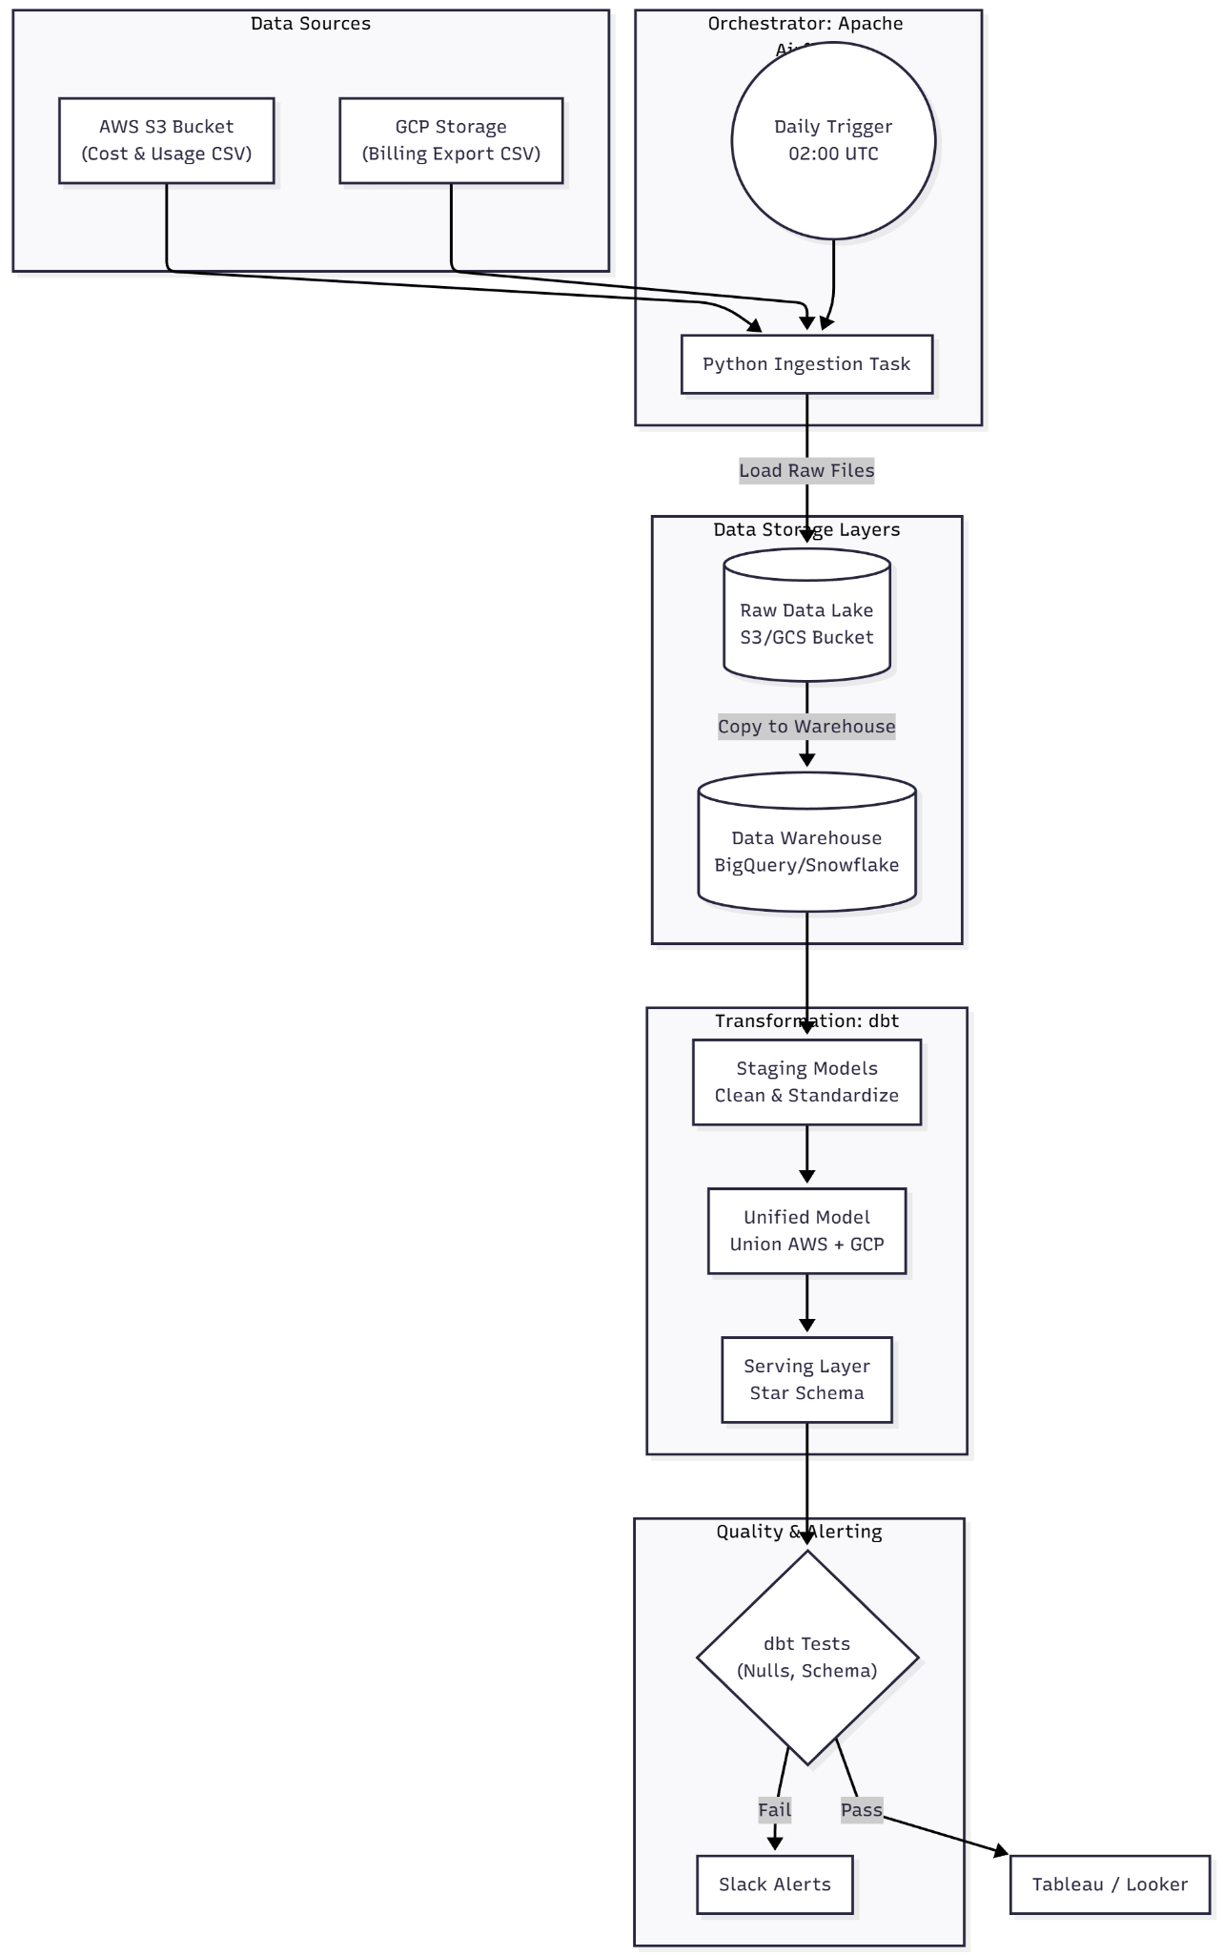
Pipeline Design Diagram:

